Lecture 3:

Office Hours Tue 1-2

Paul - Friday 3-4 p.m.

Dnyanada - Wed 3:30-4:30

Assignment 3 (day trading with Oracle)

Quiz 1 Oct 2-4, Python + Numpy)

Can use pandas, numpy etc ……

For your assignment, put returns as %,

round them to two decimal digits

reminder: in all your computations, never round variables, except to display in tables

For question 6 (b) we will ask the following:

if the oracle gives you wrong advice on the worst 10 trading days (in other words, it tells you to buy on these days), you profit will be lower.

Also for question 6 - over 5 years total

Best trading das(s) - largest values in return column

in Python, sub-slicing of a list x (with primitive elements) gives you a new object y. Changes in x are not visible in y

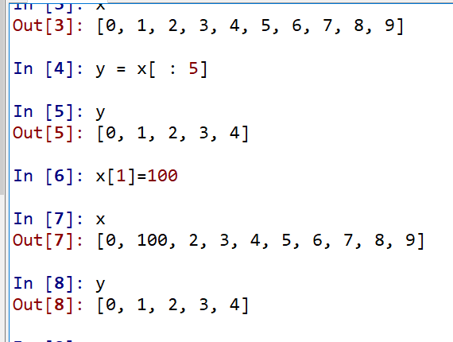

in numpy (and in Pandas) sub-slicing of x gives you a “view” y (not a separate object)

changes in x are visible in y

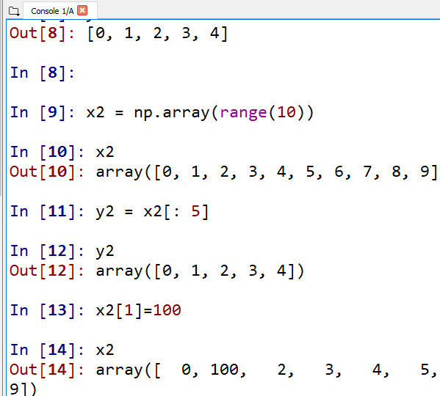

You have to be extremely careful in subslicing, subsetting, etc of dataframes

Example of statistical functions:

suppose you have a pandas dataframe df with columns “Return”

mean_return = df[“Return”].mean()

std_returns = df[“Return”].str()

df_neg = df[df[“Returns”]<0]

mean_neg_return= df_neg[“Return’].mean()

Suppose you wanted to compute your 5 annual tables:

for next_ year in [2015,2016,

2017,2018,2019]:

df_annual = df[df[“Year”]==next_year]

---- compute your mean and st. dev

---- print results for your tables

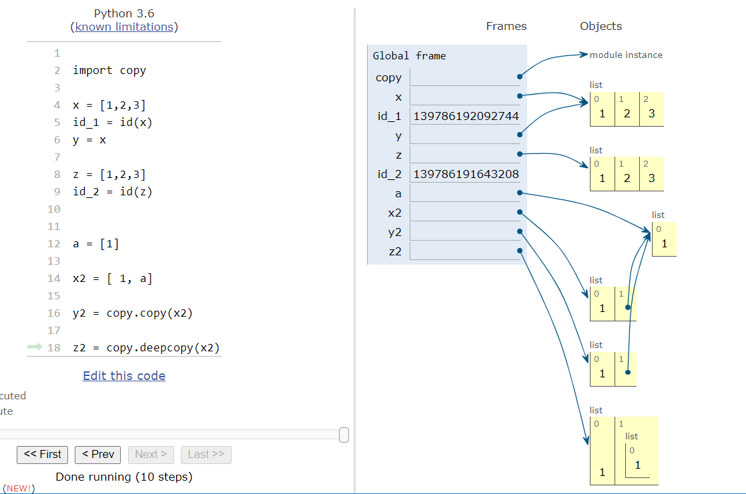

Do NOT FORGET to TAKE QUIZ 1